Analysis of a Red-Tailed Hawk Wing

Load and Stress Analysis

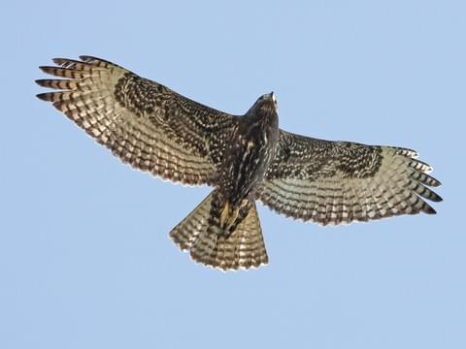

Evan Hanson, Section 001

Thomas Brewster, Section 002

Jace Pivonka, Section 002

## 

## Components:

This analysis looked at a simplified version of a single extended hawk wing reacting to the force of average flight conditions as well as those from pulling out of a dive. The wing analyzed had a 1.5 meter wingspan (0.75 meters per wing) and the bird had a mass of 1.7 kg and it was assumed that all of the mass was located in the center of the body of the bird, with the wings assumed to be massless. The overall size and geometry of the wing are shown below in figure 1.

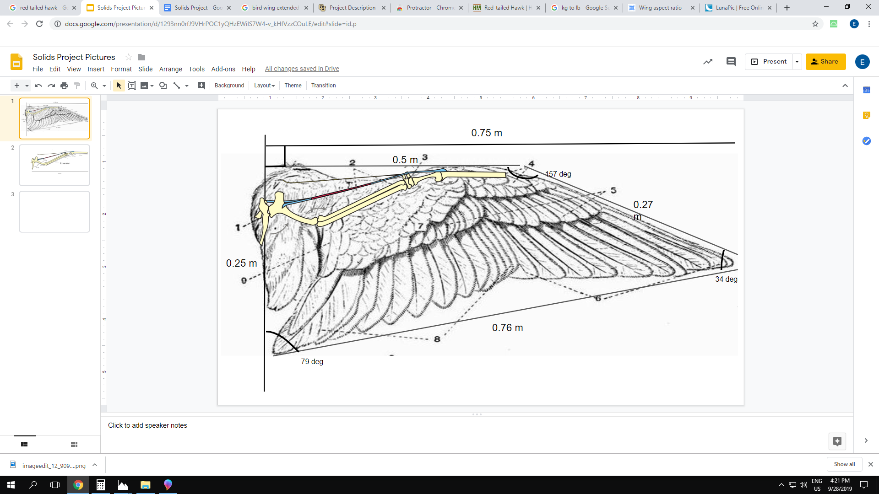

**Figure 1:** The dimensions and bones in an unsimplified red tailed hawk wing.

## Forces on Wing:

Due to the simplified mass of the bird, it was assumed that all of the downward force from the bird acted at the inside and along the neutral axis of the wing, shown by the red arrow in Figure 2. For analysis, it was assumed that the bone connects from the shoulder to the tip of the wing, with a uniform diameter and wall thickness throughout, and acts as a prismatic beam. The only other force acting on the wing was a distributed load that acted across the surface of the wing. This load was again simplified down and treated as a distributed load acting only along the simplified bone structure. This load varies along the length of the wing as the wing chord changes, increasing in areas of larger chord and decreasing in areas of smaller chord. It is assumed that the wing loading across the wing is constant. Using these forces, a force balance of $ΣF_{y}=-(1/2)mg+L=ma_{y}$ was found, where L represents the force of the distributed load. Only half of the total bird weight was considered in this equation because the weight of the bird will be equally distributed between the two wings. When the weight and distributed load are equal, the bird will not be accelerating in the y-direction. However, when the hawk angles downward and the distributed load L drops below the value of the weight, the bird will accelerate downwards in a dive. At some point in this dive, the bird will pull up and the force balance will switch so the bird is accelerating upwards once L becomes greater than the force due to the weight of the bird, creating the maximum loading condition. For this project, only the normal loading where the bird isn’t accelerating and the maximum loading condition as the bird pulls out of the dive were considered.

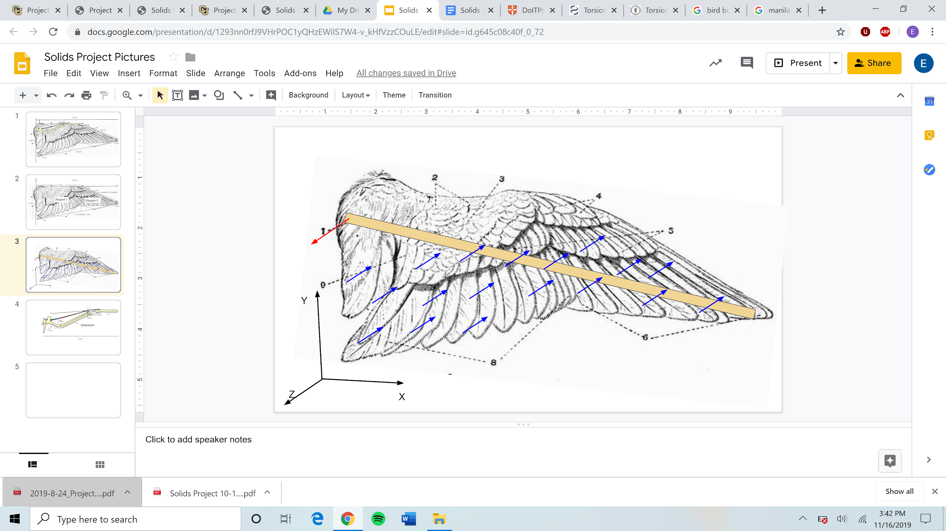

**Figure 2:** A simplified hawk wing using the single bone simplification. This diagram also shows the coordinate directions used during the analysis.

For this project, it was assumed that the bird had constant acceleration and that any air resistance that was not considered in the wing loading L was negligible. Using the constant acceleration equations, the acceleration of the bird as it pulls out of its dive was found. To calculate this acceleration, it was assumed that the bird gains 10 meters of height. Using these numbers, a researched initial velocity in the y-direction just before the bird pulls out of the dive of 53.65 m/s (120 mph), and the assumption that it has zero vertical velocity after pulling out of the dive, it was possible to calculate the acceleration of the bird in all phases of flight.

## Materials:

This analysis focused on the effects on a hawk wing due to average flight as well as while pulling out of a dive. The main material needed to do so is the bone of the red-tailed hawk. Based on an article by Biewener, the estimate for bone diameter in hawk wings is 5 cm with a wall thickness of 2 mm. The bone is a prismatic beam with a cross section shown below in Figure 3. Additionally, the bone is assumed to be a brittle material and all deformation is in the linear elastic portion of the stress strain curve because necking does not occur. The assumption of linear elasticity is critical in order to make calculations possible. Additionally, based on the article by Biewener, the ultimate bending strength of a Bobwhite Quail’s tibia is 226.3 $MN/m^{2}$, which will be used in this analysis due to the overall similarity in terms of size and mass of the two birds.

**Figure 3:** Simplified cross section of the hawk wing showing diameter and wall thickness.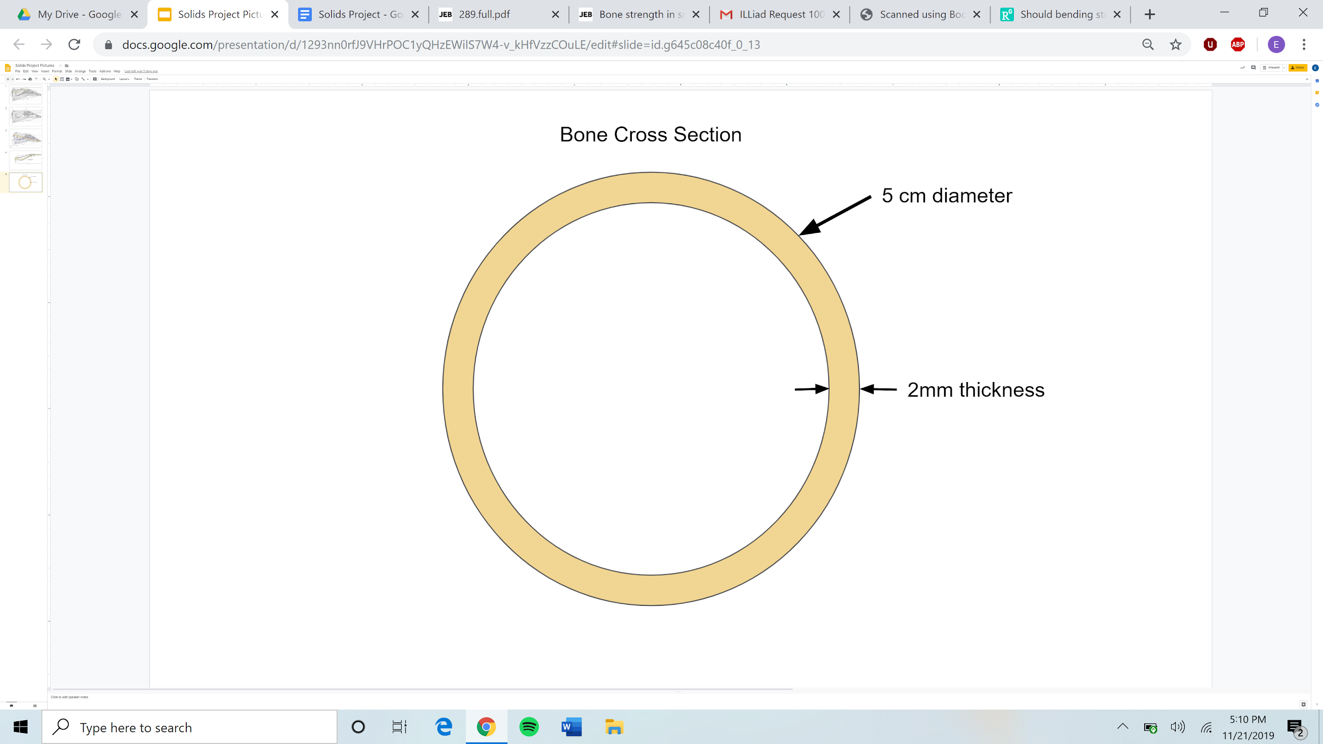

The article by Soons was used to find the modulus of elasticity which was determined to be 7.3GPa. Below is a list of cross sectional properties including the modulus of elasticity found in this article.

Cross Section Properties:

Modulus of Elasticity [E] = 7.3 GPa

Second moment of area [Iz] = $46219.898 {mm}^{4}$

Polar second moment of area [J] = $92439.797 {mm}^{4}$

Ultimate Bending Strength[$S_{UB}$] = 226.3 MPa

## Load Estimates:

In order to estimate the force L applied to the wing in the two identified phases of flight, the researched heights and the constant acceleration equations were used to find three values of acceleration, a. From those values, the known mass, and the force balance equation, approximate values of the wing loading, L, were calculated. These estimates for a and L are shown below.

Typical Loading

a = 0 $m/s_{}^{2}$

L = 8.34 N (Upward)

Extreme Loading

a = 72 $m/s_{}^{2}$

L=130.67 N (Upward)

Using these estimates of L, the forces on the simplified bone in the wing in both states of flight were found using the wing chord and bone length as well as trigonometry. From this information, all of the remaining required information for the rest of the analysis was found.

## Calculating Loads on the Wing:

To calculate the distributed load across the wing, the width and area as a function of x were found. In this scenario, it was assumed that the force acted across the entire wing evenly and the wing supports act like a solid surface extending over the entire length of the wing. The wing was split up into two sections, bounded by 4 lines. The absolute value of this was taken in order to return a positive width. Additionally, for calculations requiring cross sectional area, a uniform height of 2 cm was assumed across the wing and that the cross section is rectangular with the width of the wing varying as described by the equations shown in Figure 4.

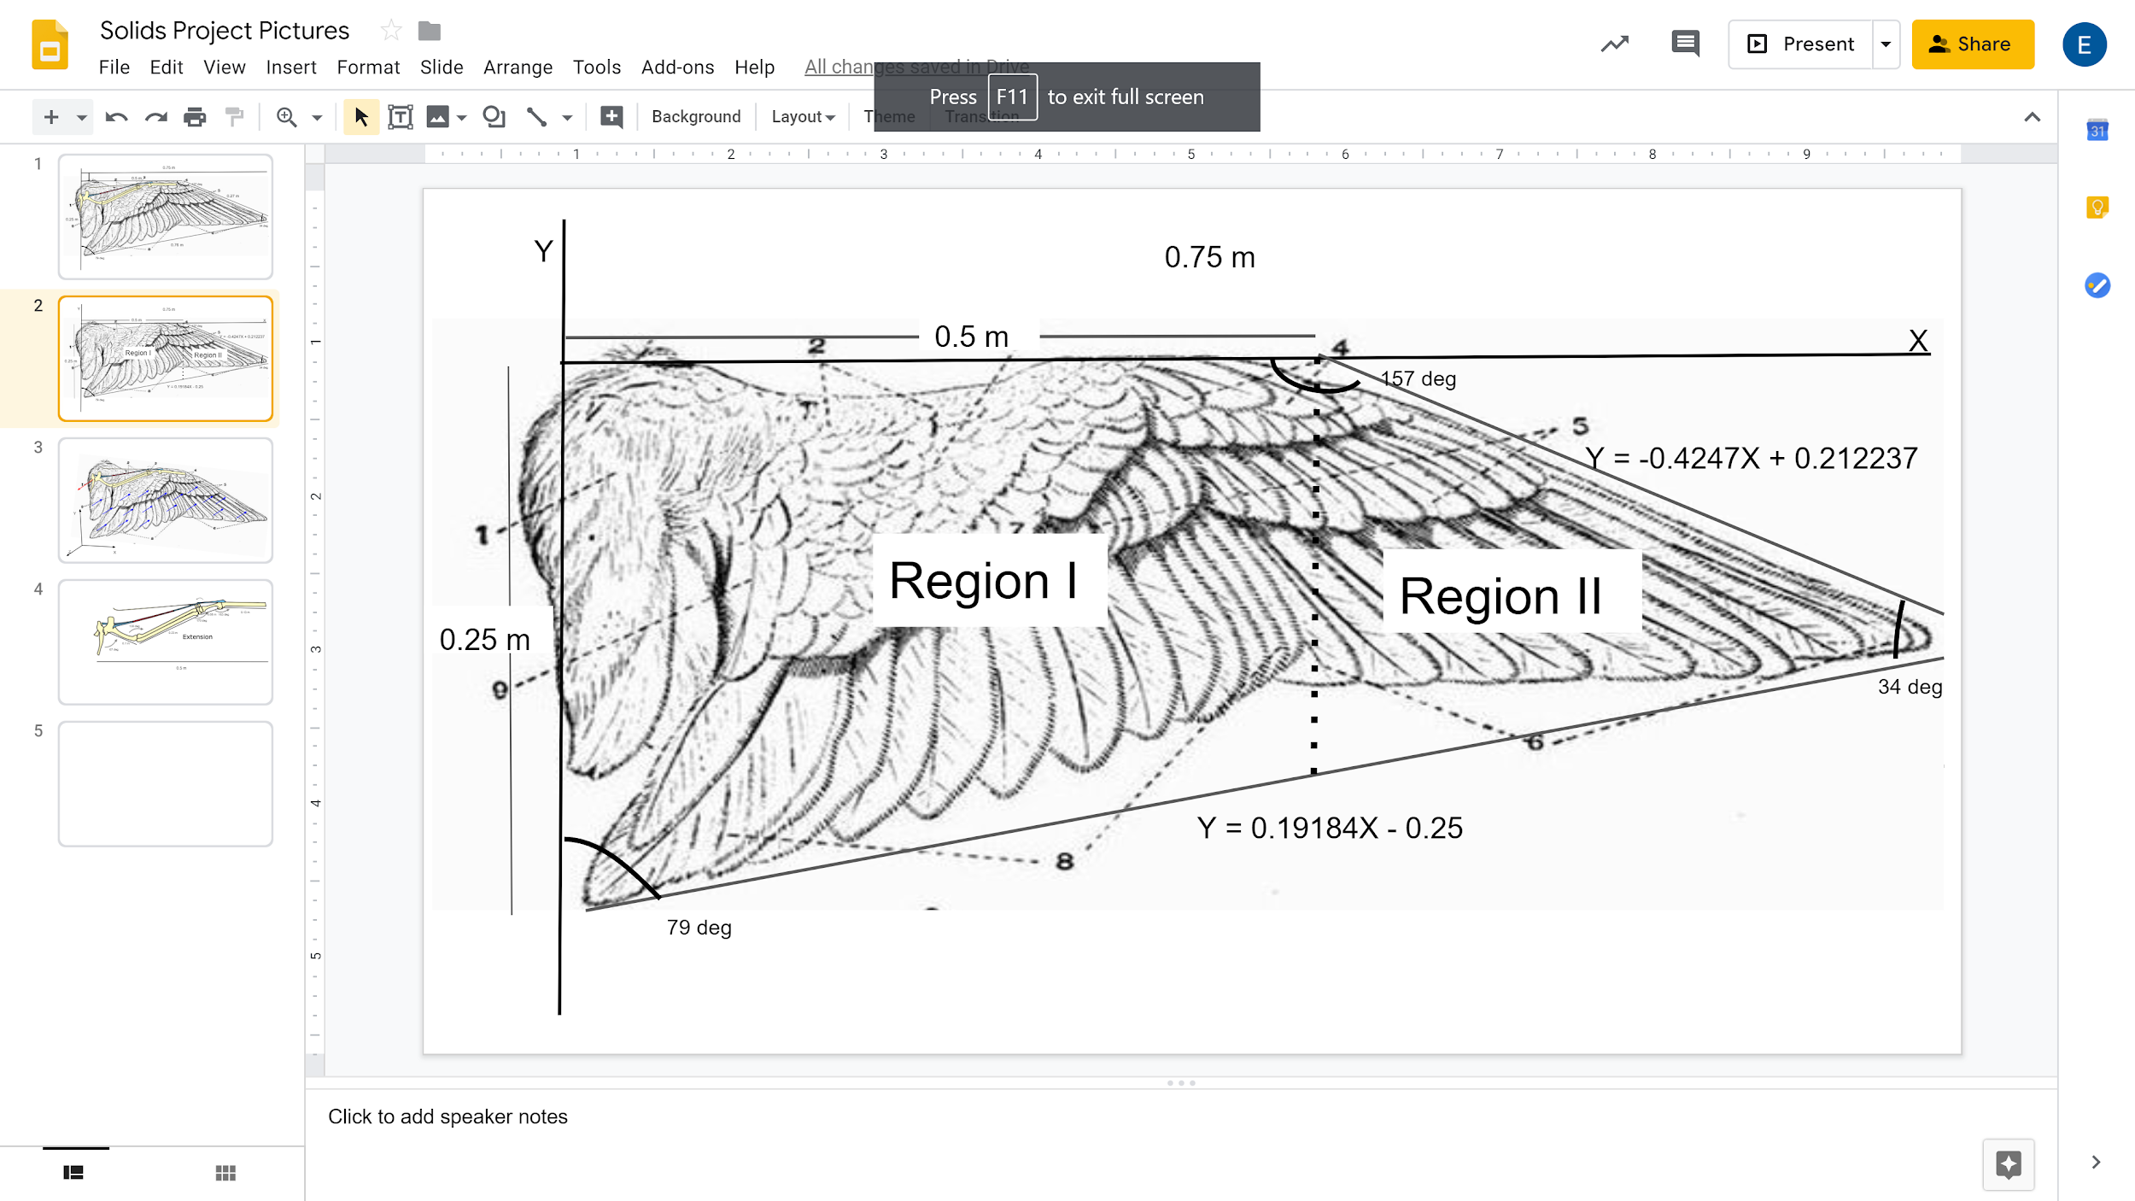

**Figure 4:** Equations for the area of the hawk wing. This image also depicts the two regions of the wing that were used during analysis.

$Width{}_{Region I} = -(0.1918417279*x-.25)$ for $0<x<0.5$ (1)

$Width{}_{Region II}=$ $-((0.1918417279*x-.25)-(-0.4244748164*x+0.2122374082))$ for (2)

0.5<x<0.75

Total area = $\int_{0}^{0.5}{}Width{}_{Region I} dx+\int_{0.5}^{0.75}{}Width{}_{Region II} dx =0.1203m^{2}$

In each case, the value of L was distributed over the area of the wing evenly, therefore the distributed force on the wing is $L/(Area{{}_{Total})}_{}$.

Typical Loading

$L= 8.34 N/0.1203m^{2} = 69.33 N/m^{2}$

Extreme Loading

$L= 130.67 N/0.1203m^{2} = 1086.20 N/m^{2}$

The Distributed Force was multiplied by the width equations to get the distributed load diagrams. The left plot in figure 5 shows the different forces that occur under the wing’s typical loading, and the right shows the forces on the wing under extreme loading.

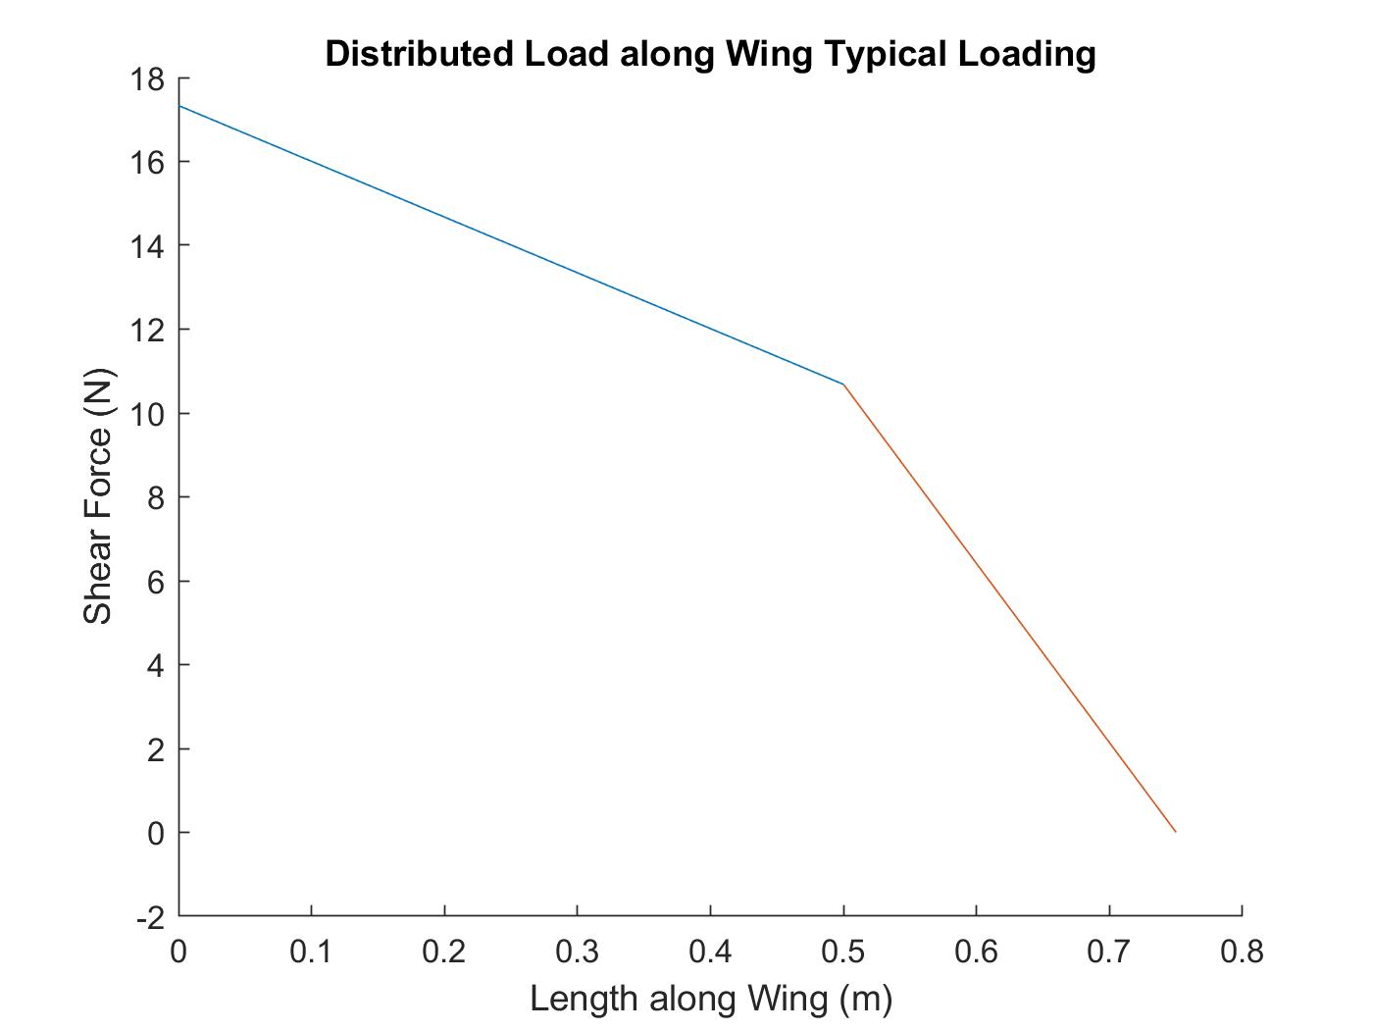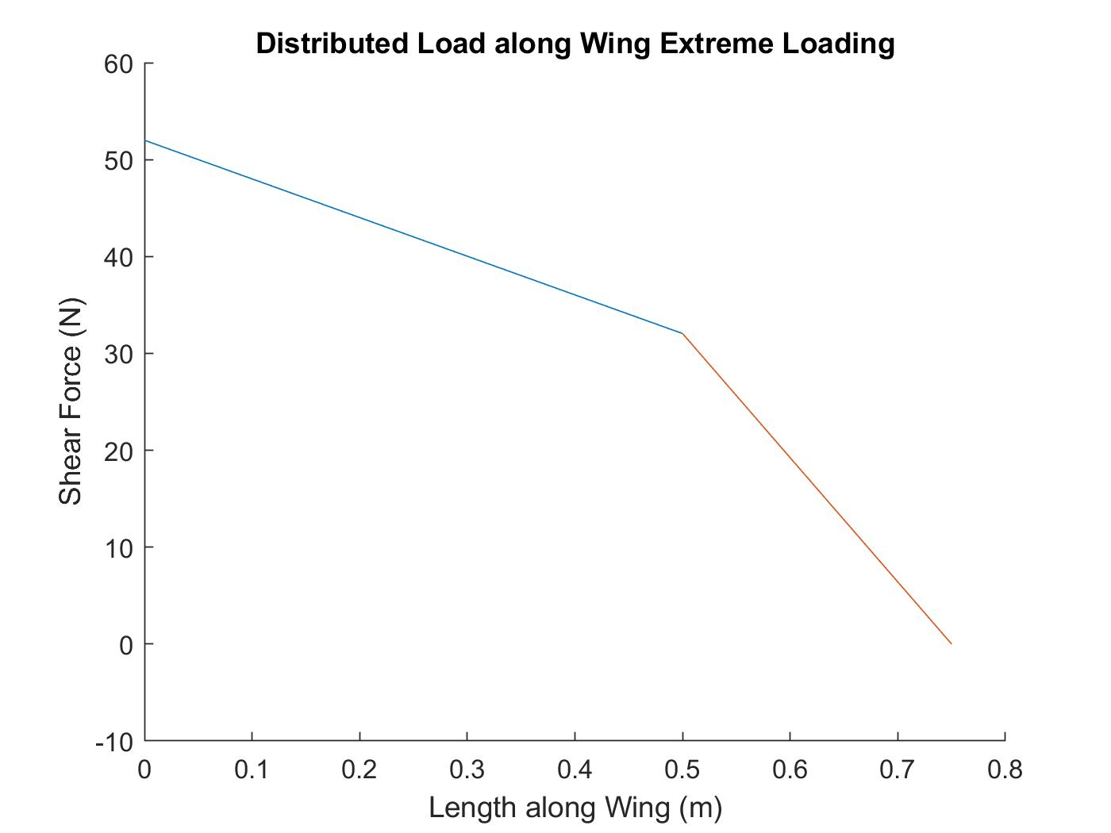

**Figure 5:** Plots of the distributed force L acting on the wing under typical and extreme loading conditions.

The plots in Figures 6 and 7 show the internal shear force and bending moment for both typical and extreme loading conditions. Calculations for internal shear and bending moment can be found in Appendix A.

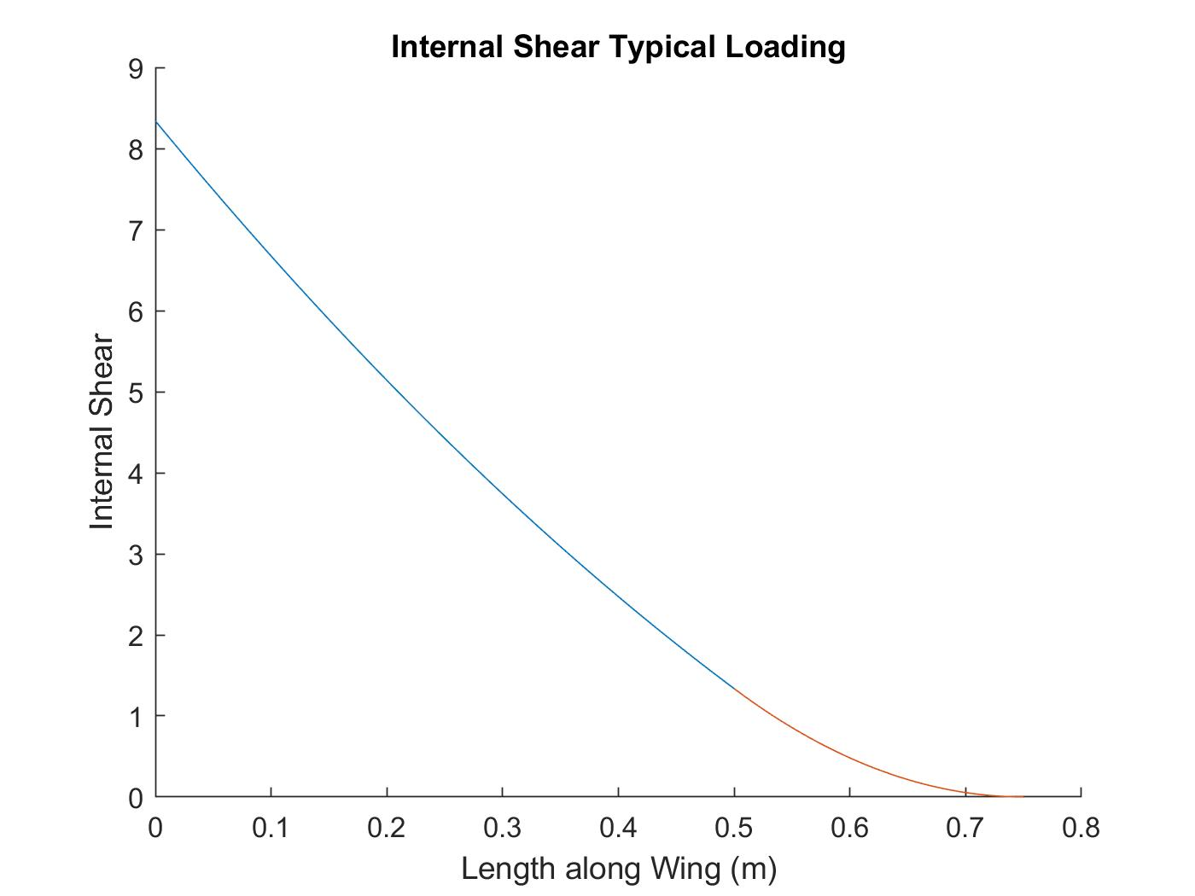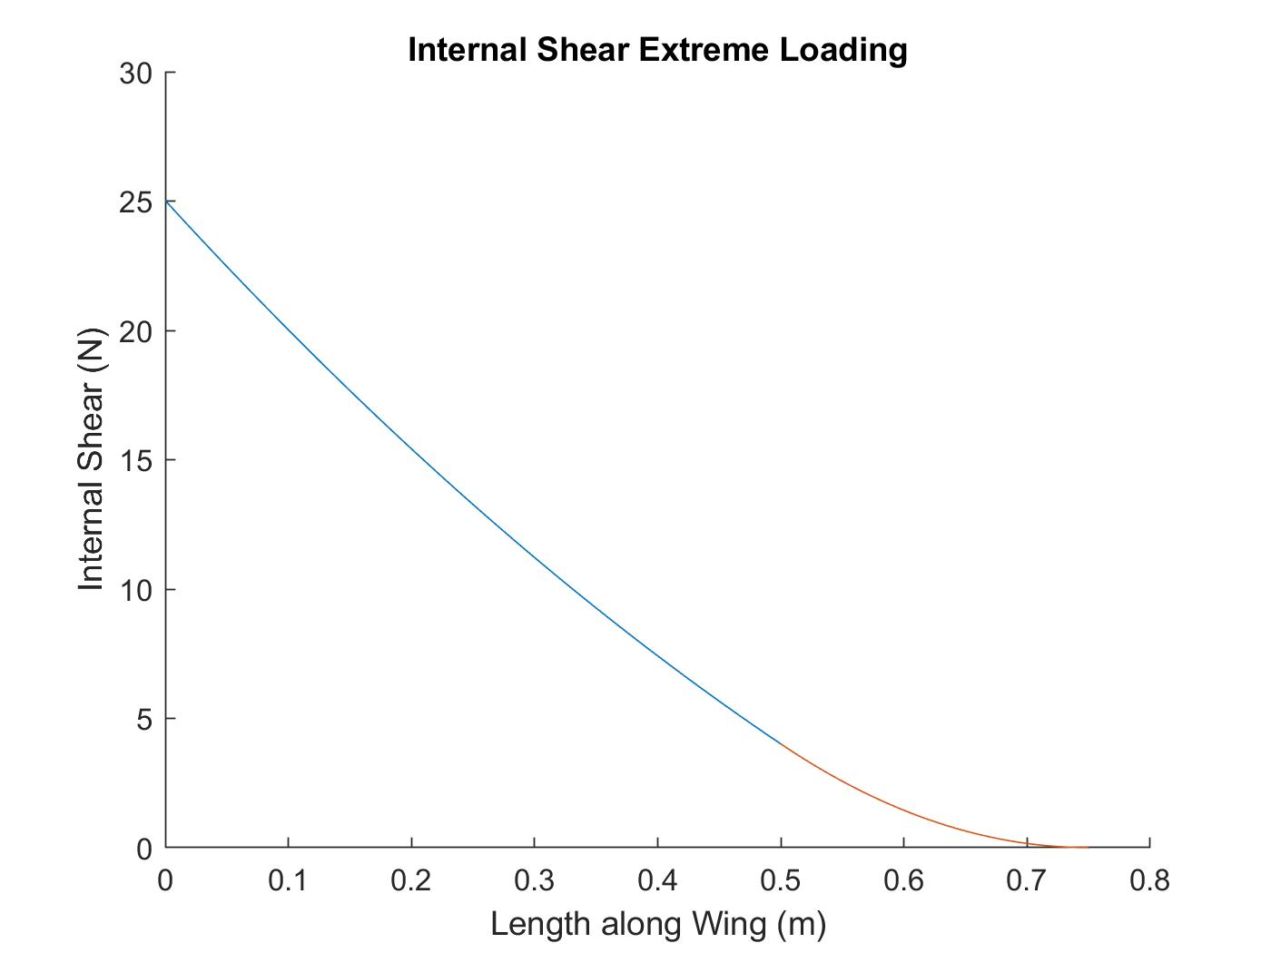

**Figure 6:** These plots show the internal shear forces throughout the wing as a function of distance from the center of the wing. The typical loading is shown in the left plot and the extreme loading is in the right plot.

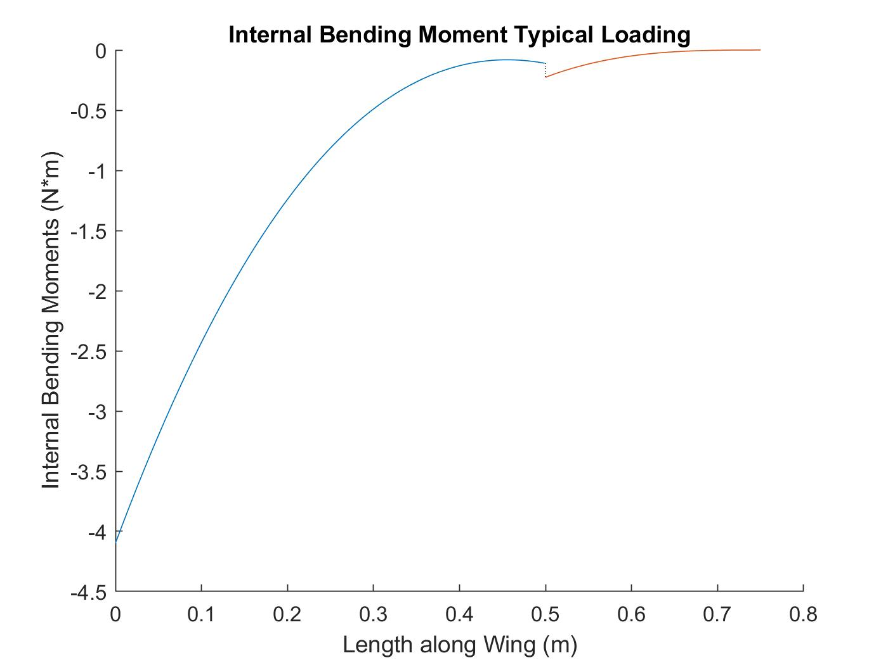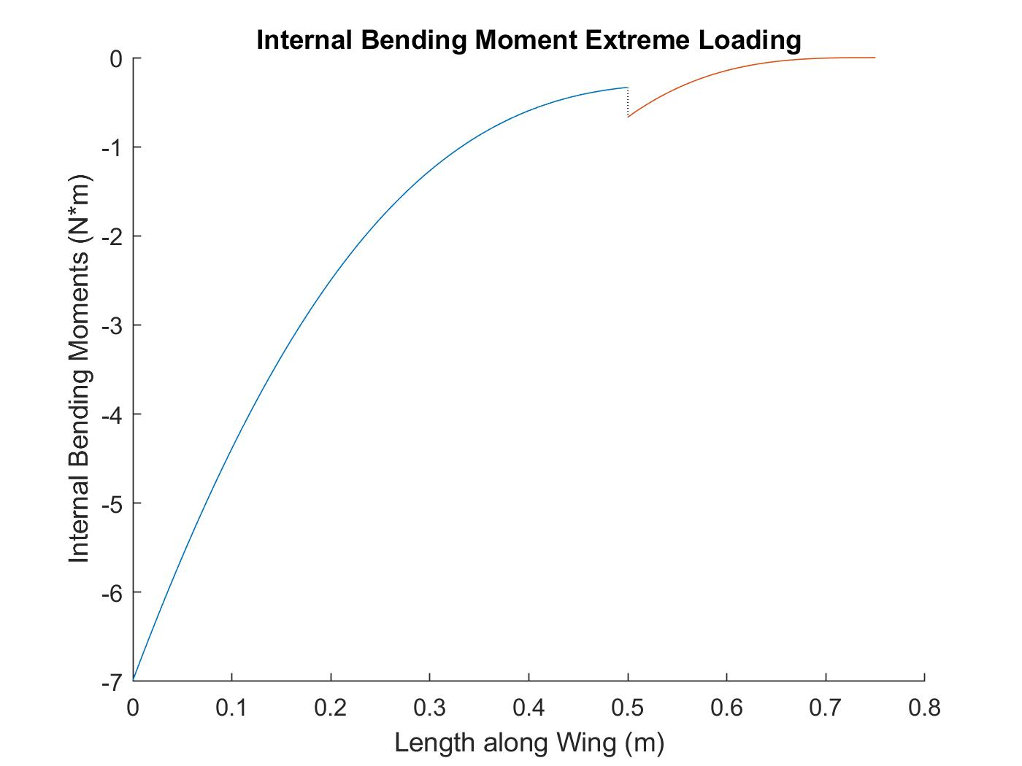

**Figure 7:** These plots show the internal bending moments in the wing as a function of distance from the center of the wing. The typical loading condition is shown in the left plot and the extreme loading condition is shown in the right plot.

Calculating loads on the bones:

In order to calculate the maximum shear stress, the maximum internal shear was found to be at $x=0$ m, measured from the center of the wing. This value was then divided by the cross sectional area at that point, yielding

$τ_{typical}=VQ/tI_{z}=.009$ MPa (3)

$τ_{extreme }=0.027$ MPa (4)

Using these stresses, the maximum bending stress was calculated using the assumption that the cross section of the bone is a hollow circle with a diameter of 5 cm and a thickness of 2 mm, as shown in figure 3. Using these values, it was found that the maximum bending stress under typical loading is roughly 2.22 MPa and the maximum bending stress under extreme loading is 3.79 MPa. The calculations for point B on the side of the bone yielded values of zero for the bending stress because the point is located at the datum so all values returned zero. These calculations are shown in the appendix.

The bending and shear stress values were plugged in to a mohr’s circle, one each for the average and extreme loading conditions. This returned the maximum shear and bending stress for each scenario which was used below in the failure prediction for the bone. For point A on the top of the bone (Shown in figure 8), the maximum shear was found to be 1.1 MPa and the maximum bending stress was found to be 2.2 MPa under typical loading. The maximum shear and bending stress under extreme loading conditions were found to be 1.9 MPa and 3.8 MPa respectively. The 3D Mohr’s circles used are shown in the appendix.

Failure Prediction:

For failure prediction, the maximum tensile stress was compared to the ultimate bending stress $S_{UB}$ using Mohr’s Failure Criterion. This is because in brittle materials which only operate in the linear elastic region of the stress strain curve, the ultimate tensile strength is less than the ultimate compressive stress. Testing for the ultimate bending stress causes tension on one side of the beam and equal compression on the other, therefore the failure will be due to the tension. As a result, it was assumed that the ultimate tensile stress was equal to the ultimate bending stress. From research, only the ultimate bending stress of a bird bone was found. Even though the ultimate tensile stress will be less than the ultimate compressive stress, to be conservative in the analysis it was assumed that the ultimate tensile stress equals the ultimate compressive stress.

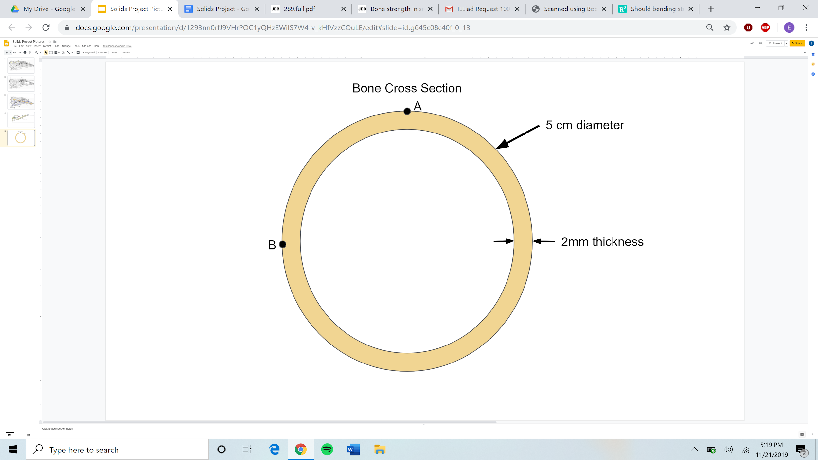

**Figure 8:** This image shows the cross section of the bone with point A labelled on the top of the bone and point B on the side.

Below are calculations for the maximum normal stresses on the top outer surface (point A) and side outer surface (point B) of the bone at $x=0$ m for both typical and extreme loading conditions. Note that for point B the safety factor is listed as N/A. This is because all of the stresses at this point were equal to zero because of the choices of the datum. In order to calculate the factor of safety, we found the $σ_{Max Tension}$ for the top and side of the bone. We then took those values and divided the ultimate tensile stress by them to find the factors of safety as shown below.

Top surface (point A):

Bending stress

Typical: Extreme:

$σ_{1}= 2.22 MPa$ $σ_{1}=3.79 MPa$

$σ_{2}=0 MPa$ $σ_{2}=0 MPa$ $σ_{Max Tension}=2.22 MPa$ $σ_{Max Tension}=3.79 MPa$

Factor of Safety:

${0≤σ}_{1}$ ${0≤σ}_{2}$ N = $S_{UT}/$ $σ_{Max Tension}$ (5)

Typical: Extreme:

N = 101.94 N = 59.71

By using the values above for both bending and extreme loading at a point on the top of the bone, it was found that the factor of safety under typical loading equals 101.94, indicating that the forces the bone is subjected to under normal conditions is approximately 102 times less than the ultimate tensile strength. Under extreme loading, the forces the bone is subjected to are 59.71 smaller than the ultimate tensile strength as well. As shown in the calculations, the factor of safety drops by almost 50% when the conditions go from typical to extreme indicating a large increase in the force on the bird wing bone. This very large factor of safety indicates that there is a very large window of forces in which a hawk can fly without risking breakage of bones.

Side Surface (point B):

Bending Stress

Typical: Extreme:

$σ_{1}=0 MPa$ $σ_{1}=0 MPa$

$σ_{2}=0 MPa$ $σ_{2}=0 MPa$

Factor of Safety:

$σ_{2}{≤0≤σ}_{1}$ $\frac{1}{N}={\frac{σ_{2}}{S_{ut}}-\frac{σ_{1}}{S_{uc}}}_{}$ (6)

Typical: Extreme:

N = N/A N = N/A

After calculating the normal and shear stress values for the side of the bone, point B, it was found that all of these values are equal to zero. Due to this result, the factor of safety could not be calculated for point B on the side of the bone because the formula for factor of safety results in division by zero when the principal stresses are equal to zero. As a result of these calculations, the factor of safety does not provide any useful data in reference to the side of the bone.

Deformation Under Loading:

To solve for the deflection of the wing, the system was idealized into a cantilever beam with a trapezoidal distributed load that was used to find the bending moments for both extreme and typical loading, shown above in the section detailing failure prediction. Deflection occurs due to the distributed load force from the air pushing up along the wing. Using the bending moment equations, we used the double integration method to calculate the deformation in the wing. The deformation is plotted below in Figure 9, with the direction of the wing flipped from the previous graphs. The body of the bird is at $x=0.75$ m and the tip of the wing at $x=0$ m. The double integration calculation can be found in the appendix.

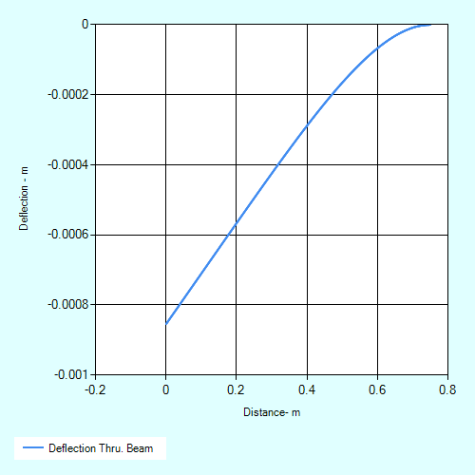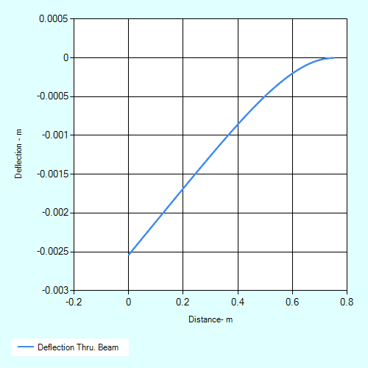

**Figure 9:** The plot on the left shows the deflection in the wing bone under typical loading conditions. The plot on the right shows the loading under extreme loading conditions.

In addition to the double integration method, which in this case is the more accurate method as detailed below, a solidworks simulation was used in order to calculate the deflection in the beam. In order to create this simulation, equation one was multiplied by the value of the distributed load, L, resulting in a force in Newtons. This equation was applied to the model as a non-uniform pressure force. An additional fixture was added at the left side of the beam in order to simulate the body of the bird. Using this set up and additional material properties found in Chen et al., Gillis, and Reed et al., the models in figure 10 were derived. Both of these models are under estimates of the deflection calculated through the double integration method because this model only used equation 1 while the double integration method used equation 2. The typical loading model yielded a maximum deflection of 7.224E-2 mm at the tip with the extreme yielding a deflection of 1.132 mm at the tip. When compared with the double integration method, the typical loading was a full order of magnitude off due to the difference in load equations while the extreme loading resulted in approximately half of the deflection from double integration.

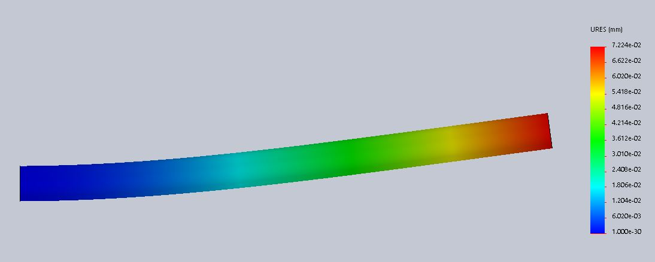

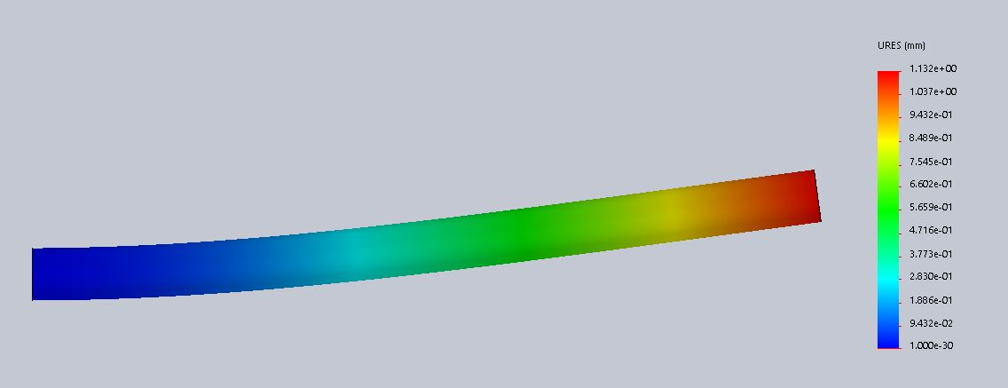

**Figure 10:** These images show the deflection simulations performed in solidworks. The top image shows the deflection under typical loading while the lower image shows the deflection under extreme loading.

Team Roles:

Throughout this project, our three team members functioned exceptionally well together. Evan Hanson served as the primary team leader ensuring that we started our deliverables early. He also headed outside communication through meeting with professors and TAs whenever the group encountered a problem as well as working through a significant portion of the Matlab coding for the early stages of the project. Thomas Brewster did a significant part of the hand calculations that were based on the values that we found using Matlab. He also completed the materials section at the beginning of the analysis and made contributions to the formation of the report. Jace Pivonka completed the Mohr’s circle calculations and drew them out as well as working through the failure and factor of safety calculations. He also did a significant amount of work tying all of the report together and ensuring that the formatting and phrasing was uniform and professional throughout.

Appendices:

A: Internal Shear and Moment Diagrams

Method of sections: The shear and moment equations are transposed by x’ = (0.75-x) allowing 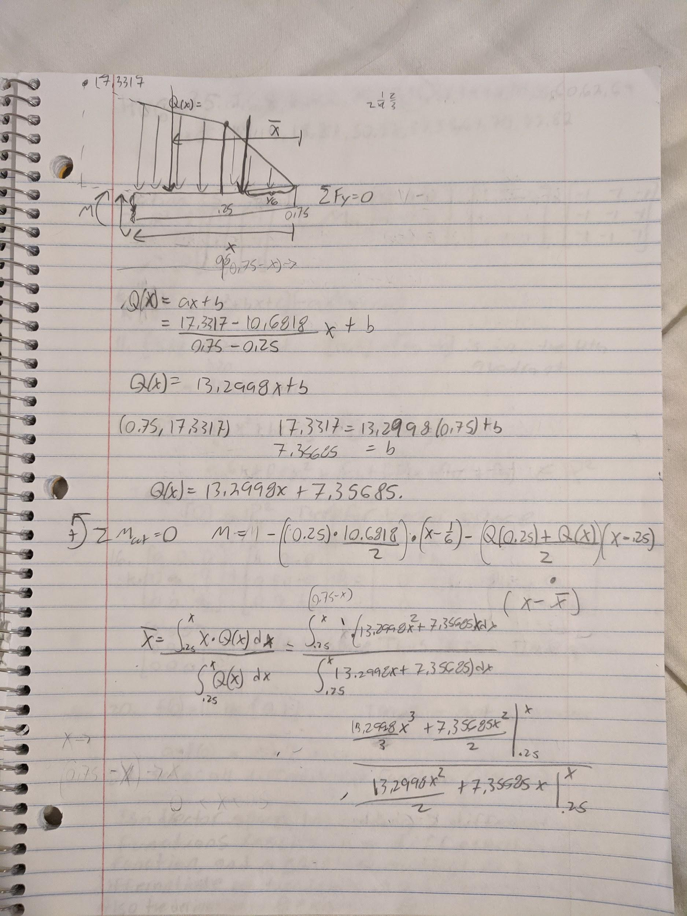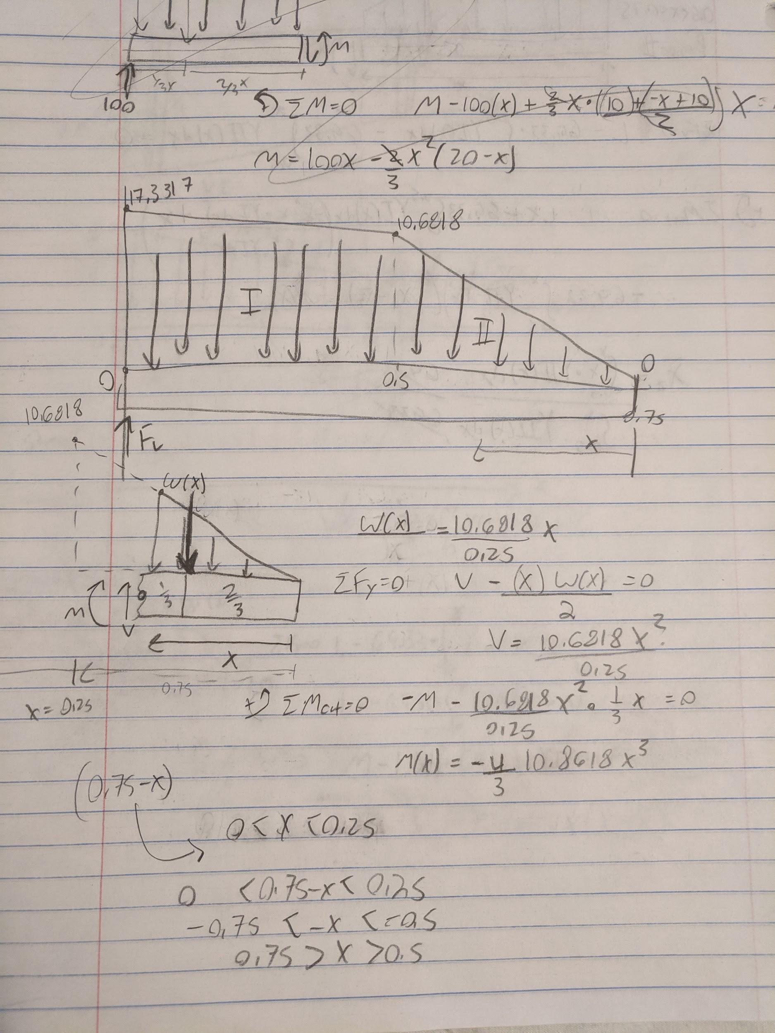

MATLAB to graph the resulted equations.

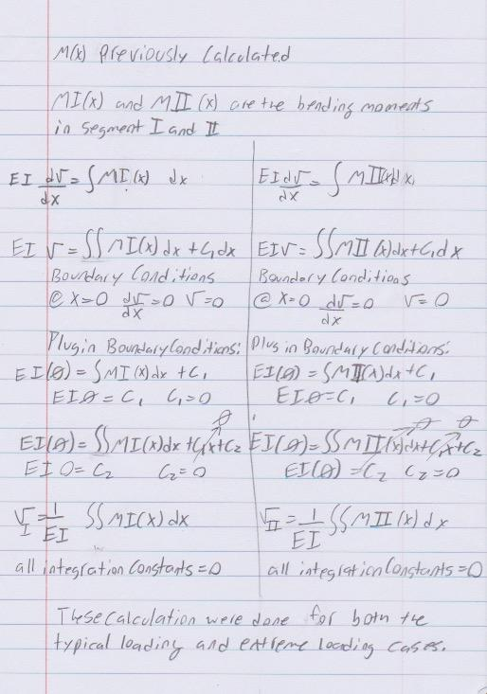

Double integration: Integrating the internal moment equation for section I and II of the wing to find the equations of deformation. Specific equations were calculated through MATLAB.

B. Maximum Bending Stress

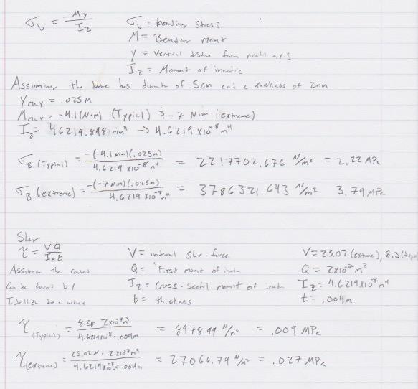

This figure shows the calculations for the max bending and shear stresses for both the typical and extreme loading situations.

C: Mohr’s Circle

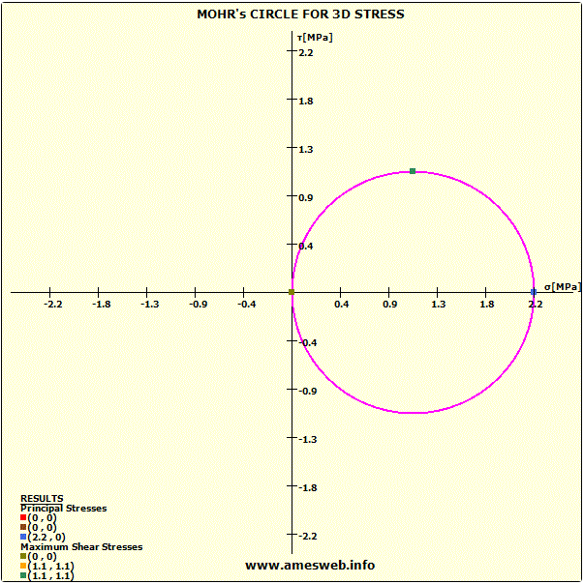

This Mohr’s circle shows the stresses under normal loading. The 3D stresses are present in this figure but are too small relative to the principal stresses to appear on the circle.

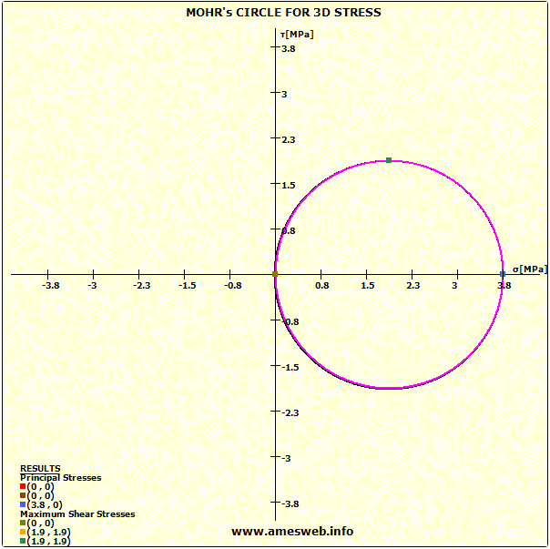

This Mohr’s circle shows the stresses under extreme loading. The 3D stresses are present in this figure but are too small relative to the principal stresses to appear on the circle.

Works Cited:

Biewener, A. A. (1982). Bone strength in small mammals and bipedal birds: do safety factors

change with body size? Journal of Experimental Biology, 289–301.

Chen, P., Lin, A., Lin, Y., Seki, Y., Stokes, A., Peyras, J., … Mckittrick, J. (2008). Structure and

mechanical properties of selected biological materials. *Journal of the Mechanical Behavior of*

*Biomedical Materials*, *1*(3), 208–226.

Gillis, G. B. (2010, September 1). WEIGHING IN ON BIRD BONES. Retrieved December 11, 2019.

Reed, K. L., & Brown, T. D. (2001). Elastic Modulus and Strength of Emu Cortical Bone. *The Iowa*

*Orthopaedic Journal*, *21*, 53–67.

Soons, J., Herrel, A., Aerts, P., & Dirckx, J. (2012). Determination and validation of the elastic

moduli of small and complex biological samples: bone and keratin in bird beaks. Journal

of the Royal Society, Interface, 9(71), 1381–1388.